Organisation: Crawley Town Community Foundation
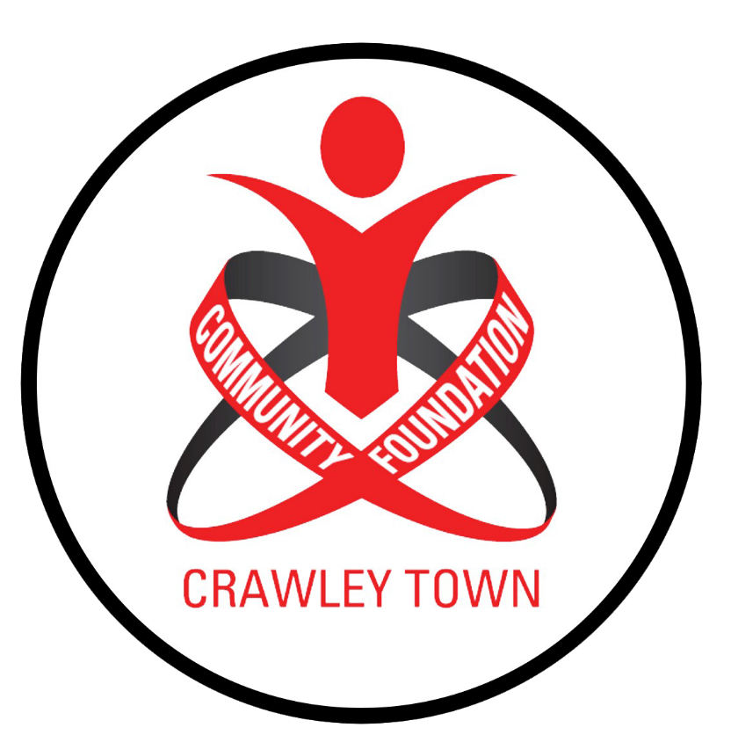
Job: Community Development Coach
Salary: £15-16,000 pro rata (dependent upon experience)
Location: The People’s Pension Stadium and locations within the community.
Type of contract: 20 Hours per Week
Reporting to: Community Development Manager

Job Description
To plan, deliver and implement our successful Community Development programmes to a high standard, providing quality, professional coaching and activities that are progressive and reflective of the needs of people accessing our provision.

Our Community Development projects aims to provide young people to access activities based upon the specific objectives of the projects and of the needs of the participants, as well as promoting and supporting, development of the Crawley Town Community Foundation.
The candidate must be prepared to work unsociable hours and have access to transport for all sessions.

Applicants for the post will need to have the following:
- A 1st4Sport FA Level 2 Certificate in Coaching Football (Essential).
- FA Youth Award (Desirable).
- Sports coaching awards in other sports. (Desirable)
- Coaching disability sports. (Desirable)
- Valid emergency first aid, safeguarding certification. (Essential)
- A full UK driving licence and a car you have access to for all sessions. (Essential)

The successful applicant will be required to deliver sessions within a range of community settings, using excellent organisation, time management and communication skills. You must be highly motivated, enthusiastic & have a pro-active approach to working flexible hours as and when the role requires.

Key Responsibilities:

- Support the Premier League project co-ordinator to implement the strategy based upon the set aims and objectives required by the Premier League Charitable Fund.

- Ensure all Community Development programmes are delivered to a high standard and incorporate relevant safeguarding and health and safety procedures.

- Establish and maintain positive working relationships with individuals/organisations from all sections of the community.

- Support the Community Development Manager with the development of projects, where required.

- Actively promote all provision delivered by the Crawley Town Community Foundation.

- Includes developing other partnerships in Crawley and surrounding areas – for example with relevant sports development teams / networks, football and sports clubs, youth organisations, community facilities / centres and local / regional / national partners, parents, children and volunteers.

Person Specification:

Duties and Responsibilities (Specific)

- To deliver a range of activities at a local level with a focus on inclusion and increasing participation levels.

- To prepare and implement, structured and progressive programmes ensuring high quality, enjoyable coaching experiences are delivered, being centred on the needs of the participants.

- To take positive steps to identify and overcome barriers to participation amongst the community from disadvantaged backgrounds, prioritising access and inclusion, using the Crawley Town FC brand to encourage participation.

- To support work with clubs and other community groups to ensure that young people are retained in sport through high quality provision.

- To assist in supporting participants with their personal development via a number of different courses/opportunities, and exit routes.

- To be a positive role model, creating a positive and fun environment in which to motivate and encourage members of the community to participate in sport, physical activity or other Community Foundation projects.

- To effectively supervise, mentor and direct support staff and volunteers where appropriate.

- To be committed to continuous professional development relevant to the post and personal training needs supporting future career advancement.

- To maintain current knowledge of relevant EFL Trust and Premier League policies and practices.

- To carry out administrative duties as necessary e.g. maintain accurate attendance registers, carry out risk assessments, gathering data and promoting the Community Foundation.

- To develop and maintain effective and positive working relationships with all partners and community organisations.

- To agree to abide by a code of conduct and carry out duties in accordance with Club policies, including equal opportunities, safeguarding children, health and safety at work, etc.

To be prepared to regularly carry out work during evening, weekend and school holiday periods. The list above is not exhaustive and may change where necessary.

Health & Safety:

1. To be responsible for the safety, health and welfare of himself/herself in accordance with the Health and Safety at Work etc Act 1974, related legislation, the Club’s Safety Policy, and operating guidance notes produced by the Foundation.

2. The post holder will also be expected to promote the Foundation’s policies and procedures on Health and Safety.

3. To ensure safeguarding, risk assessments and service level agreements with partners are in place

Protection of children and vulnerable adults:

1. The post requires regular contact with under 18's and vulnerable adults in a supervisory role.

2. The post requires collection of information about children and vulnerable adults taking part in activities.

3. The post involves making sure risk assessments on activities/facilities relating to under 18’s and vulnerable adults events are carried out.

